Pricing Strategy

# 1. Executive Summary

This document outlines the findings from a pricing optimization analysis aimed at improving profitability. Our analysis reveals that by understanding how different customer segments react to price, we can adjust our strategy dynamically.

The key finding is that by implementing a segment-specific pricing framework, we can achieve a **potential profit increase of approximately 8.9%**. This strategy involves targeted price decreases for price-sensitive segments to drive volume and modest price increases for less sensitive segments to improve margins. We recommend a phased rollout of this strategy, starting with A/B testing on the highest-impact product segments.

# 2. Data Preprocessing and Feature Engineering

To build a reliable model, we began by cleaning the raw sales data from Amazon of Apr’22 to Jul’22 (~120k records). This involved standard procedures like handling missing values, removing duplicate entries, and ensuring data consistency.

The most critical step was moving beyond broad product categories. We engineered two key features to create more granular customer segments:

* **Category Type:** Grouping similar products into logical types (e.g., 'Dress', 'Set', 'Kurta').
* **Price Segment:** Classifying each SKU into 'Premium', 'Average', or 'Economy' tiers based on its historical price points.

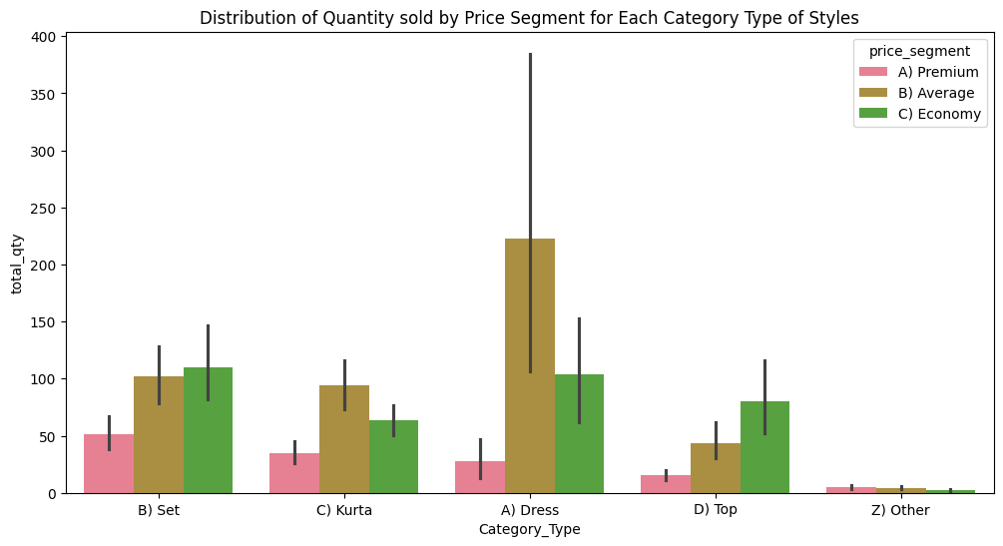

These features allowed us to analyse customer behaviour with a much higher degree of precision.

*NOTE: Since the cost price is not available, we have used an assumed cost price for each Style: Assumed Cost = Historical Average Price * 0.60*

# 3. Demand Curve Estimation & Segmentation Analysis

We discovered that customer price sensitivity (elasticity) is not uniform across our products; it varies significantly depending on the product type and price segment.

To quantify this, we fit a log-log linear regression model for each segment. This model estimates the Price Elasticity of Demand, telling us the percentage change in quantity sold for every 1% change in price. Data is prepared by creating weekly aggregations by Style to prepare time series data for elasticity modelling.

## Key Insights from Segmentation:

* **Highly Elastic Segments:** Customers in segments like Dress - Premium (Elasticity: -4.01) and Set - Economy (Elasticity: -1.52) are very sensitive to price. For these groups, a calculated price *decrease* can lead to a disproportionately large increase in sales volume, maximizing overall profit.
* **Inelastic Segments:** Customers in segments like Set - Average (Elasticity: -0.75) are far less sensitive to price. This group, which represents nearly 25% of our total revenue, presents an opportunity for modest price *increases* to improve profit margins without significantly impacting sales.
* **No Clear Elasticity Trend**: Do not apply price changes to segments with insignificant p-values/anomalous elasticities. These are "no-decision" zones for now. Further analysis or more complex models are required to propose pricing changes.

|  |  |  |  |  |
| --- | --- | --- | --- | --- |
| **Category Type** | **Price Segment** | **Elasticity Segment** | **Elasticity** | **Key Insight** |
| B) Set | B) Average | B) Inelastic | -75.5% | This is a very large segment and it's inelastic. A major finding for profit growth. |
| B) Set | C) Economy | A) Elastic | -152.9% | Economy sets follow the expected pattern of high price sensitivity. |
| C) Kurta | B) Average | A) Elastic | -102.6% | A classic elastic segment where price is a key purchasing driver. |
| A) Dress | B) Average | C) Excluded | 56.9% | No conclusive evidence of price effect. |
| C) Kurta | C) Economy | B) Inelastic | -67.1% | Economy Kurta buyers are less price-sensitive than other economy segments. |
| B) Set | A) Premium | C) Excluded | 46.7% | The relationship is not strong enough to act on. |
| D) Top | C) Economy | A) Elastic | -187.8% | A classic elastic segment where price is a key purchasing driver. |
| D) Top | B) Average | C) Excluded | 121.2% | Anomalous: Suggests other factors (promotions, trends) were the real drivers of sales. |
| A) Dress | C) Economy | A) Elastic | -272.9% | As expected, buyers of economy dresses are highly sensitive to price. |
| C) Kurta | A) Premium | A) Elastic | -135.7% | Similar to premium dresses, premium kurta buyers are also price-sensitive. |
| A) Dress | A) Premium | A) Elastic | -401.4% | Surprisingly, premium buyers are the most price-sensitive. Major optimization opportunity. |
| D) Top | A) Premium | C) Excluded | 48.0% | No reliable price effect was found. |
| Z) Other | B) Average | B) Inelastic | -37.7% | A small but clearly defined inelastic segment. |
| Z) Other | C) Economy | C) Excluded | 7.6% | No price effect detected. |
| Z) Other | A) Premium | C) Excluded | 55.5% | The model is not confident in this relationship. |

# 4. Dynamic Pricing Simulation & Framework

Based on these findings, we developed a dynamic pricing framework that blends mathematical optimization with real-world business constraints.

## The Proposed Framework:

1. **For Elastic Segments (Elasticity < -1):** We use a profit-maximization formula to calculate the optimal price point that balances a lower price with higher volume.
   1. Calculated Price = Cost * (Elasticity / (1 + Elasticity))
   2. Apply the guardrails to get the final price:
      1. New Price = max( Min Allowable Price, min(Calculated Price, Max Allowable Price))
      2. This is for preventing any extreme or brand-damaging adjustments.
2. **For Inelastic Segments (-1 < Elasticity < 0):** We simulate a cautious 5% price increase to capture more margin.
3. **For Excluded Segments:** For segments where our model was not statistically confident, we recommend holding prices steady.

# 5. Evaluation & Financial Impact

Running our historical sales data through this simulation framework yielded significant positive results.

* **Baseline Profit (Analyzed Segments):** ₹2.60 Cr
* **Simulated Profit (Analyzed Segments):** ₹2.83 Cr
* **Total Potential Profit Increase:** **+₹23.1 Lakhs (+8.9%)**

The profit lift is driven by a combination of strategies. For instance, the large, inelastic Set - Average segment contributed over ₹5.4 Lakhs in additional profit from a modest price increase. Conversely, the elastic Set - Economy segment added nearly ₹6.0 Lakhs in profit from a calculated price decrease that drove higher sales.

# 6. Recommendations & Next Steps

1. **Phased Rollout with A/B Testing:** We recommend launching an A/B test for the new pricing on the highest-impact segments (e.g., Set - Average and Set - Economy). This will allow us to validate the model's predictions in a controlled environment before a full-scale implementation.
2. **Investigate Anomalous Segments:** A few segments showed either no clear price sensitivity or counter-intuitive results. These should be investigated further to understand if other factors like promotions or fashion trends are the primary drivers of demand.
3. **Enhance the Model with More Data:** For future iterations, we should enrich this model with additional data sources, such as promotional calendars, inventory levels, and seasonality. This will improve the accuracy of our elasticity calculations and allow for even more sophisticated scenario testing (e.g., modelling the impact of a holiday promotion).